OCI Integration
Download ATP Wallet

Table of Content

Purpose statement 1
Download Wallet 1

Purpose statement
The purpose of this document is to illustrate the steps to download the client credentials (Wallet) for ATP

Download Wallet
- To download client credentials, navigate to Oracle Cloud Infrastructure Console Oracle Database Autonomous Transaction Processing.

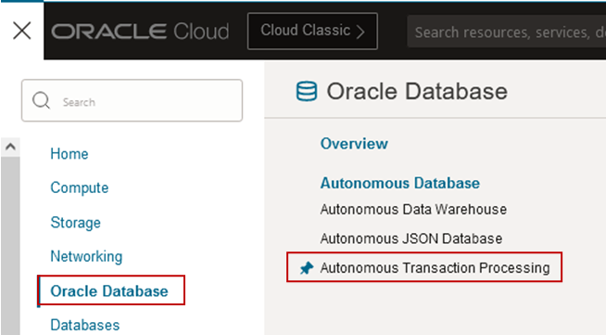

- Choose the Compartment where the ATP resides then select the ATP
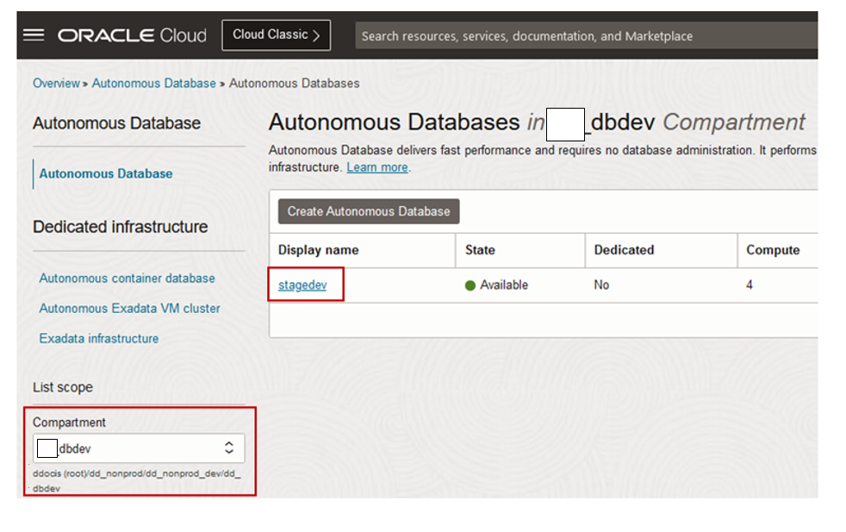

- From the Autonomous Database details page Click DB Connection.

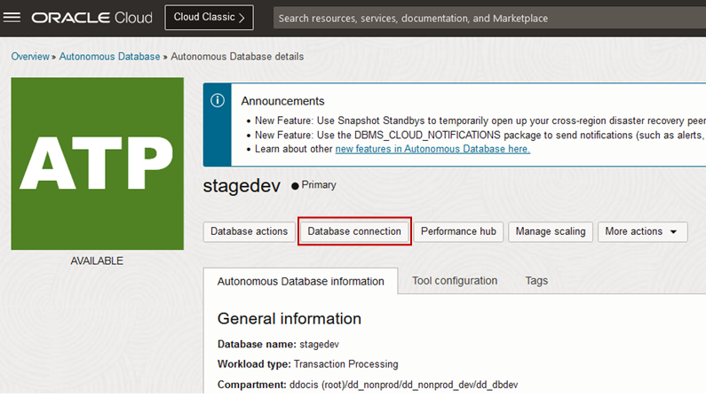

- On the Database Connection page select the Wallet Type as Instance Wallet then click Download Wallet.

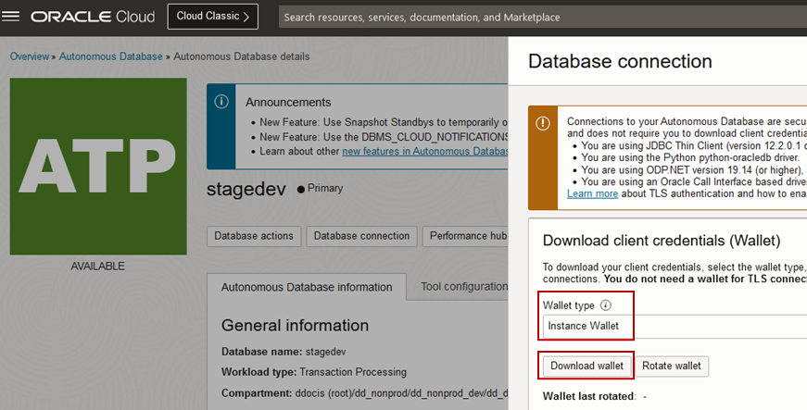

Note: Wallet for a single database only; this provides a database-specific wallet. (Oracle recommends you provide a database-specific wallet, using Instance Wallet, to end users and for application use whenever possible.)
- In the Download Wallet dialog, enter a wallet password in the Password field and confirm the password in the Confirm Password field.
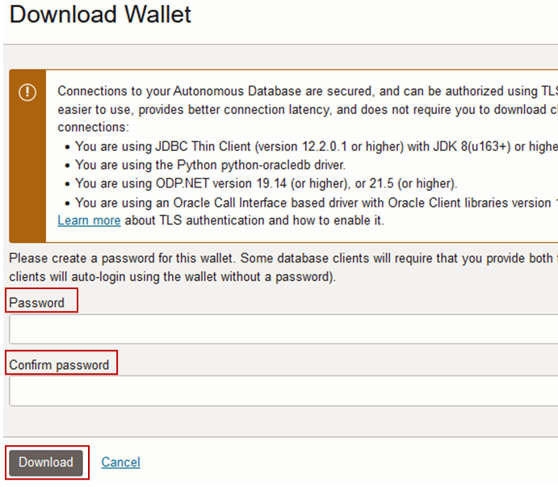
Note: The password you provide when you download the wallet protects the downloaded Client Credentials wallet. For commercial regions, the wallet password complexity for the password you supply requires the following:
- Minimum of 8 characters
- Minimum of 1 letter
- Minimum of 1 numeric character or 1 special character
- Click Download to save the client security credentials zip file. By default the filename is: Wallet_<databasename>.zip. You can save this file as any filename you want. (Protect this file to prevent unauthorized database access.)

### END ###

